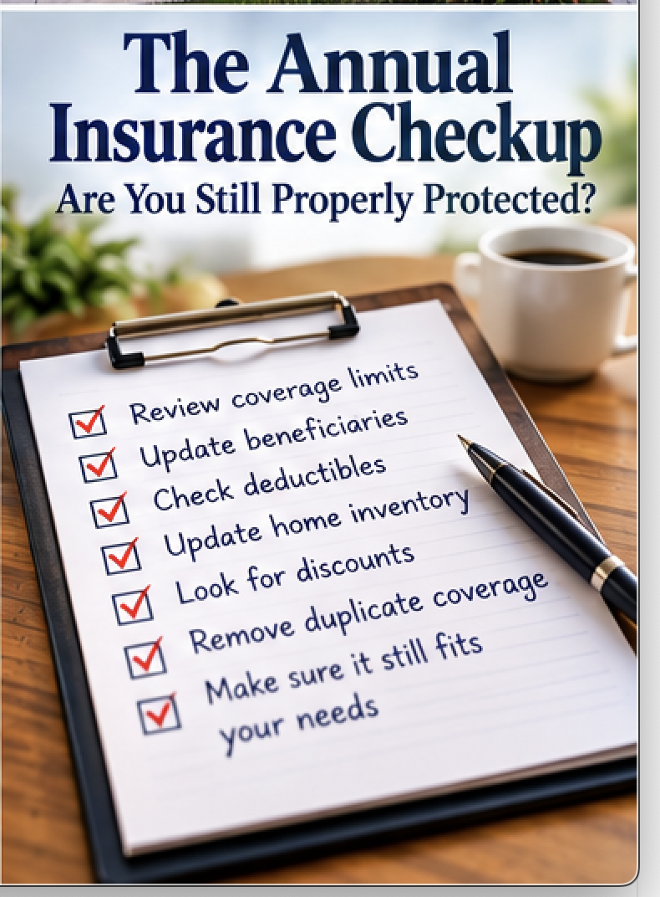
The Annual Insurance Checkup: Are You Still Properly Protected?
Insurance has a peculiar habit of disappearing from our attention after we buy it. We insure the house, cars and lives, put the policies in a drawer—or more likely an online account—and continue paying the premiums year after year. Meanwhile, everything the policies are supposed to protect keeps changing.
Start With the House
Have you remodeled the kitchen, finished the basement, built an addition or made other substantial improvements? Construction costs may also have risen since the policy was issued.
Review the dwelling limit and ask whether it reasonably reflects current rebuilding costs rather than simply the house's market value.Check whether personal property is covered at replacement cost or actual cash value. The difference can substantially affect what you receive after a loss.
Update the Home Inventory
Walk through the house with your phone once a year. Photograph significant new purchases. Update appraisals when appropriate. Remove property you no longer own and make sure particularly valuable items have adequate coverage.
The NAIC recommends reviewing replacement values and adjusting coverage as property changes.
Review the Cars and Drivers
Did you buy or sell a vehicle? Is somebody new driving one of your cars? Has an older vehicle declined enough in value to reconsider collision or comprehensive coverage?
Check your deductibles as well. A $250 deductible selected years ago might be unnecessarily expensive today if you now have enough savings to comfortably absorb $500 or $1,000. Conversely, don't increase a deductible merely to reduce the premium if paying it after an accident would create a financial hardship.
Revisit Life Insurance
Marriage, divorce, death of a spouse, retirement, a paid-off mortgage and financially independent children can all change the need for life insurance. Check the beneficiaries. An outdated beneficiary designation can create serious problems.
If you own permanent insurance, review its cash value, death benefit, premiums and any outstanding policy loans. Don't surrender or replace an older policy casually. Understand what you have before giving it up.
Check Liability Limits
Assets and income can grow while liability limits remain unchanged for decades.
Review the liability limits on homeowners, renters and auto policies. If your financial exposure has increased substantially, ask whether those limits remain appropriate and whether an umbrella policy deserves consideration.
The NAIC specifically includes liability limits among the items consumers should examine during an insurance review.
Look for Duplicated Coverage
More insurance isn't automatically better insurance. You might be paying an auto insurer for roadside assistance already supplied by an automobile club. A credit card may provide certain travel or rental-car benefits. Employer or association benefits can sometimes overlap with separately purchased protection.
Don't cancel anything until you know precisely what each source covers, but there is little benefit in unknowingly paying twice for the same limited service.

Shop Carefully, Not Automatically
Loyalty to an insurer is fine if the coverage, service and price remain competitive. But periodically obtaining comparable quotes can tell you whether they still are.
Make sure comparisons use the same coverage limits and deductibles. A quote that appears hundreds of dollars cheaper may simply provide hundreds of thousands of dollars less protection.
Ask about legitimate discounts for bundling policies, safety equipment, security systems or other qualifying factors.
Read the Declaration Pages
You don't have to reread every insurance contract from beginning to end each January. Start with the declaration pages. They summarize the insured property, major coverage limits, deductibles and premiums.
Then ask yourself a simple question: If something serious happened tomorrow, would this still provide the protection I think I have?
That question is the heart of an annual insurance checkup.
Insurance should change as your life changes. The policy you bought years ago may still be exactly right.
But it's better to find that out during an annual review than after filing a claim.

